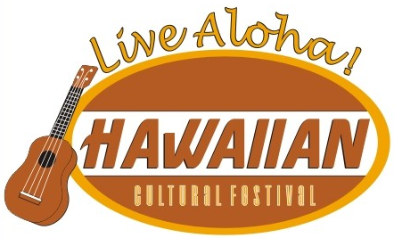

2019 LIVE ALOHA HAWAIIAN CULTURAL FESTIVAL
RELEASE AND WAIVER AGREEMENT
This Release and Waiver of Liability (the “Release”) releases the Seattle Live Aloha Hawaiian Cultural Festival, a 501(c)(3) corporation, and each of its directors, officers, employees, volunteers, and agents (“Live Aloha”). The Performer desires to perform at the 12th Annual Seattle Live Aloha Hawaiian Cultural Festival on September 8, 2019 (‘Event”).
In consideration of my application and permitting me to participate in this activity, I hereby take action for myself, my executors, administrators, heirs, next of kin, successors, and assigns as follows:
(A) I WAIVE, RELEASE, AND DISCHARGE from any and all liability, including but not limited to, liability arising from the negligence or fault of Live Aloha, any claims or damages for my death, disability, personal injury, property damage, property theft, or actions of any kind which may hereafter occur to me including my traveling to and from this activity, THE FOLLOWING ENTITIES OR PERSONS: Live Aloha directors, officers, employees, volunteers, representatives, and agents, and the activity holders, sponsors, and volunteers;
(B) I INDEMNIFY, HOLD HARMLESS, AND PROMISE NOT TO SUE the entities or persons mentioned in this Release from any and all liabilities or claims made as a result of participation in this activity, whether caused by the negligence or fault of Live Aloha.
I acknowledge that Live Aloha and their directors, officers, volunteers, representatives, and agents are NOT responsible for the errors, omissions, acts, or failures to act of any third party or entity conducting a specific activity at or during the Event.
I understand while participating in this activity, I may be photographed or filmed. I agree to allow my photo, video, or film likeness to be used for any lawful purpose by Live Aloha, such as publicity, illustration, advertising, and web content.
This Release shall be construed broadly to provide a release and waiver to the maximum extent permissible under applicable law.

I HAVE CAREFULLY READ THIS AGREEMENT AND FULLY UNDERSTAND ITS CONTENTS. I AM AWARE THAT THIS IS A RELEASE OF LIABILITY AND I ACKNOWLEDGE AND AGREE TO ITS TERMS.

Participant Signature _______________________________________________
Participant Printed name ____________________________________________
Organization Name (if applicable) _____________________________________
Address __________________________________________________________
Date _____________________________________________________________
Signature of Participant parent or guardian ______________________________
(if under age 18)

